JOHN CABOT

John Cabot was born Giovanni Caboto in Italy around 1450. By 1495, he had moved to England, with his family. He made a voyage in 1497 on the ship Matthew and claimed land in Canada—mistaking it for Asia—for King Henry VII of England.

Early Years

Cabot was the son of a spice merchant in Italy. At age 11, he learned sailing from Italian sailors and merchants.

In 1476, Cabot was trading in the eastern Mediterranean. Records indicate that he got into financial trouble and left in debt. During this time, Cabot became inspired by the discoveries of Bartolomeu Dias and Christopher Columbus. Like Columbus, Cabot believed that sailing west from Europe was the shorter route to Asia. Hearing of opportunities in England, Cabot traveled there and met with King Henry VII, who gave him a grant to

"seek out, discover, and find" new lands for England.

North American Voyages

In 1497, Cabot left England, on the Matthew, a fast ship with a crew of 18 men. Cabot and his crew sailed west and north under Cabot's belief that the route to Asia would be shorter from northern Europe than Columbus's voyage. 50 days into the voyage, Cabot landed on the east coast of North America, though the real location of this landing is subject to controversy. Some historians believe that Cabot landed at what is today Maine.

Though the records are incomplete, it is believed that John Cabot went ashore with a small party and claimed the land for the King of England. The ship sailed back to England in July 1497. Cabot was soon rewarded by King Henry VII. In February 1498, he was given permission to make a new voyage to North America.

Mysterious Ends

In 1498, John Cabot departed with five ships and a crew of 300 men. The ships carried provisions and small pieces of cloth, lace and other clothing. They were hoping to trade with native people.

On the way, one ship began to leak and sailed to Ireland, while the other four ships continued on. From this point, no-one really knows what happened on the voyage.

For many years, it was believed that the ships were lost at sea. More recently, however, documents have emerged that place Cabot in England in 1500, leading us to believe he and his crew actually survived the voyage.

Historians have also found evidence to suggest that Cabot's expedition explored the eastern Canadian coast, and might have built a settlement there.

What can be said for sure is that John Cabot claimed North America for England, setting the course for England's rise to power

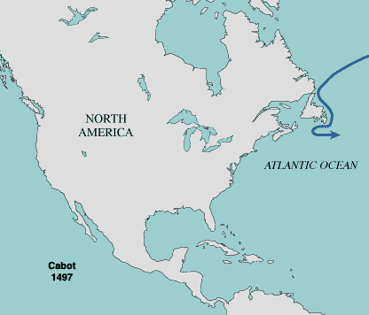

JOHN CABOT
- John Cabot was from what country?

- What was his REAL name?

- What did Cabot do when he was young?

- Which other explorers inspired Cabot?

- Which King hired Cabot?

- What did the King ask Cabot to do?

- When did Cabot leave for his voyage?

- How long did it take him to reach land?

- Why was one ship forced to return on his second voyage?

10. What are some ideas (more than one) about what eventually happened to Cabot?

11. What was one important result from Cabot’s voyage?

