**History of the Mason-Dixon Line**

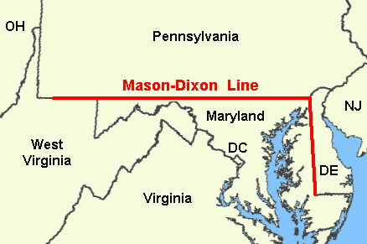

The "Mason and Dixon's Line"

was surveyed between 1763

and 1767 by [Charles Mason](http://en.wikipedia.org/wiki/Charles_Mason)

and [Jeremiah Dixon](http://en.wikipedia.org/wiki/Jeremiah_Dixon)  in the

resolution of a border dispute

between British colonies in

Colonial America.

It forms a demarcation line

between four U.S. states,

forming part of the borders

of Pennsylvania , Maryland ,

Delaware , and West Virginia

(then part of Virginia ).

The Mason-Dixon Line symbolizes a cultural boundary between the Northern United States and the Southern United States

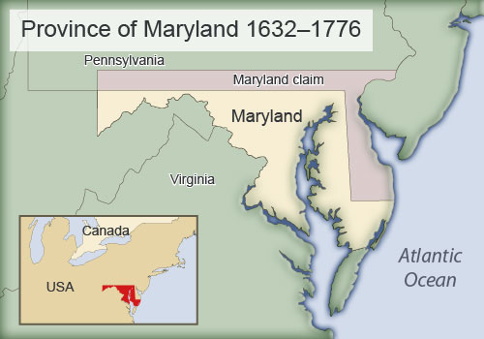

Background

Maryland and Pennsylvania both

claimed the land between the 39th and

40th parallels according to the charters

granted to each colony.

The 'Three Lower Counties' (Delaware)

along Delaware Bay was given to Penn,

and later became the Delaware Colony,

a part of Pennsylvania.

In 1732 the governor of Maryland,

Charles Calvert, 5th Lord Baltimore,

signed an agreement with William Penn's

sons which drew a line somewhere in between, and also renounced the Calvert claim to Delaware. But later Lord Baltimore claimed that the document he signed did not contain the terms he had agreed to, and refused to put the agreement into effect. Beginning in the 1730s, violence erupted between settlers claiming various loyalties to Maryland and Pennsylvania. The border conflict between Pennsylvania and Maryland would be known as Cresap's War.

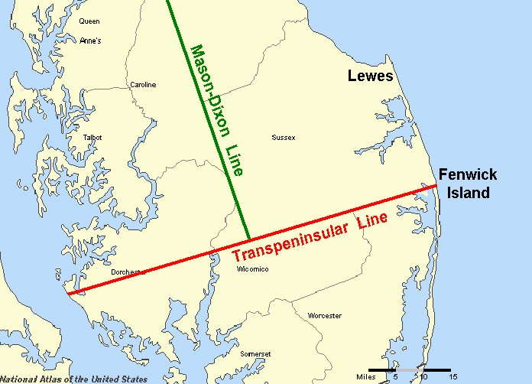

In 1751, a line was surveyed straight

across the Delmarva Peninsula

beginning at what at least some early

Swedish settlers called Cape Hinlopen,

which was to be the southern boundary

of Delaware. This place is better known

as Fenwick Island.

Twenty-four miles north is another cape

named Cape Henlopen near Lewes,

Delaware.

The confusion of the placement of

Cape Henlopen was the sticking point

in a long standing dispute between the Penns (Delaware) and the Calverts (Maryland.) The Calverts claimed that the Lewes' cape should have been the start of the boundary line.

A map commissioned by Charles Calvert in 1732, which showed Cape Henlopen at Fenwick Island, that was used to decide the matter. Calvert failed in his later attempts to have the court reject his own map. If the actual Cape Henlopen near Lewes had been used as the start of the line, Delaware would be about one thousand square miles smaller, over a third of its current area.

In 1751 a line was surveyed from the court designated point on the coast to the Chesapeake Bay (Penn's Cape Henlopen), and in turn was used by Charles Mason and Jeremiah Dixon (of Mason–Dixon line fame) in 1763 when they were engaged to survey the North/South border between Maryland and Delaware).

**Geography**



Mason and Dixon's actual survey line fixed the

boundary between Delaware and Pennsylvania

Most of the Delaware-Pennsylvania

boundary is a circular arc.

The Delaware-Maryland boundary does not

run truly north-south because it was intended

to bisect the Delmarva Peninsula

[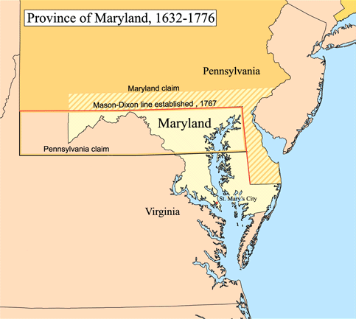](http://upload.wikimedia.org/wikipedia/commons/a/a9/Marycolony.png)

The Maryland-Pennsylvania boundary is an east-west line.

The surveyors also extended the boundary line to run between Pennsylvania and colonial western Virginia.

The Mason-Dixon Line was marked

[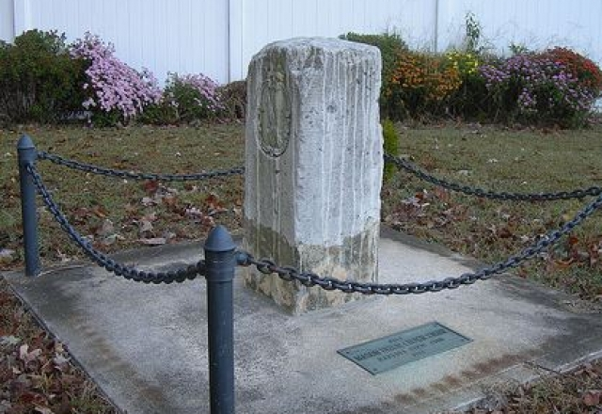](http://www.carolinehistory.org/wp-content/uploads/2013/02/Marydel.jpg)

by stones every mile and

"crownstones" every five miles,

using stone shipped from England.

The Maryland side says (M) and

the Delaware and Pennsylvania

sides say (P).

Crownstones include the two

coats-of-arms.

Today, while a number of the

original stones are missing or

buried, many are still visible,

resting on public land and protected,

