A BRIEF HISTORY OF JAMESTOWN

Jamestown Settlement

Jamestown was the first permanent English settlement in North America. It was founded in 1607 and served as the capital of the Virginia colony for over 80 years.

Setting Sail for America

In 1606, King James of England gave the Virginia Company of London permission to start a new colony in North America. They paid for an expedition of 144 men to travel to America aboard three ships. They left England on December 20, 1606.

The three ships first headed south to the Canary Islands. They then traveled across the Atlantic Ocean to the Caribbean Islands, landing at Puerto Rico for fresh food and water. From there, the ships headed north and finally, four months after leaving England, landed in Virginia on April 1607.

Jamestown

They selected a site to build a fort. The settlers explored the coast and picked an island spot that could be easily defended if they were attacked by the local natives. They named the new settlement Jamestown after King James I. They then built a triangular shaped fort for protection.

Unfortunately, the site they chose was not a good location. In the summer, the site turned into a swamp filled with mosquitoes and water that you could not drink. In the winter, it was unprotected from the harsh winter storms and became bitterly cold.

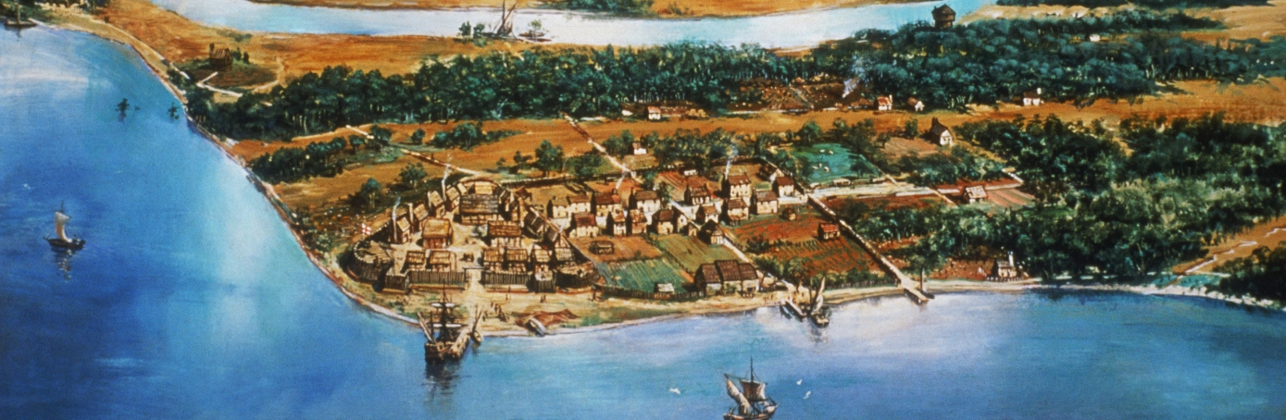

The Men of Jamestown

The first settlers of Jamestown were all men. They hoped to get rich quick and then return to England. Few were used to the hard work that it took to survive. They didn't know how to fish, hunt, or farm. Their lack of survival skills would make the first few years very difficult.

First Year

The first year was a disaster. More than half of the settlers died during the winter. Most died from diseases, germs from the water, and starvation. The settlers that did live only survived with the help of the Powhatan and a supply ship that arrived in January.

The Powhatan

The local Native Americans were part of a large group of tribes called the Powhatan. At first the settlers did not get along with the Powhatan. Some settlers were killed or kidnapped by the Powhatan when they went outside the fort.

It wasn't until Captain John Smith took over the leadership of the colony that the relationship improved. When Smith went to visit the Powhatan Chief, he was taken prisoner. Smith would have been killed but was spared when the chief's daughter, Pocahontas, saved his life. After this event, the relationship between the two groups improved and the settlers were able to trade for much needed goods.

In the summer of 1608, Captain John Smith became the president of the colony. Unlike the other leaders, Smith was not a "gentleman", but an experienced sailor and soldier. Smith's leadership gave the colony a chance to survive.

Many of the settlers didn't like Smith. He forced everyone to work and made a new rule that said "if you don't work, you don't eat." However, the rule was necessary because too many of the settlers were sitting around expecting others to build houses, grow crops, and hunt for food. Smith also told the Virginia Company to only send workers such as carpenters, farmers, and blacksmiths to the settlement.

Unfortunately, Smith was injured in October of 1609 and had to sail back to England to recover.

Starving Time

The winter after Smith left turned out to be the worst year in the history of the settlement. It is often called the "starving time" because only 60 of the 500 settlers survived the winter.

After the harsh winter, the few settlers left were determined to abandon the colony. However, when fresh supplies and colonists arrived from England in the spring, they decided to stay and make the colony work.

Tobacco

For the next few years, the colony failed to be much of a success. Things began to turn around, however, when John Rolfe suggested planting tobacco. Tobacco became a cash crop for Virginia and helped the colony to grow rapidly over the next several years.

BRIEF HISTORY OF JAMESTOWN QUESTIONS

- Which King of England gave permission to start a colony in North America?
2. Take a look at the dates on your reading. Look at when they left and when they arrived. How long did they spend at sea?

3. They did not anticipate spending that much time on the ocean so what problems do you think they had?

4. What was an important thought when they chose where they wanted to land and build?

5. As it turns out, they made a rather poor choice of location….give a few reasons why this was a poor location

1,

2,

3.

6. How many women traveled in the first group to land?

7. What skills did the men lack? Why would this be a problem?

8. Tell about the role John Smith had in “saving” the colony from destruction (starvation).

9. After the starving time, many were ready to leave. Why did they stay?

10. How did John Rolfe help the colony to make money?

