GIOVANNI DA VERRAZANO

Achievement:

In his 1524 voyage Verrazano, he recorded details unknown to European mapmakers. His discoveries changed the details of maps that would be used by explorers who came after him.

--------------------------------------------------------------------------------

The Mystery of his Early Life

There is very little known about the birth or early life of Giovanni da Verrazano. What we do know is that he was well educated and employed as a sailor for France.

Planning the Expedition

The expedition that eventually got under way in 1524 was one of the most significant events in the exploration of North America. His voyage along the North American coast lasted six months, and while he failed in his goal find a passage to China and the Far East, he completely changed other explorers’ view of the New World.

John Cabot’s 1497 voyage was well known by Verrazano. With the knowledge and information gathered by Cabot, Verrazano made his plans and preparations for his own expedition.

In 1523, letters were written to organize financial support for a voyage led by Verrazano. Interested in finding a source for silk for the textile factories, the financial supporters were among the wealthiest and most influential families in France. The support of the king, Francois I, was also necessary for the venture.

The Voyage

Verrazano left France on January 1, 1524 with a fleet of four ships. Almost immediately a storm sank two of the ships, and forced both remaining ships to return. Both ships were sent to Spain to fight a war between the two countries. Very soon, one of the ships was recalled from Spain and given to Verrazano’s voyage of exploration.

On January 17, 1524, one ship began the journey. Also on the voyage was Giovani’s brother.

Verrazano knew he had to approach the land to the west with caution. Spain had laid claim to much of the land and, thanks to Ponce de León.

Verrazano chose a mid-Atlantic destination for two reasons.
- He hoped the route would take him safely away from Spanish regions.
- He hoped to sail through the continent and gain passage to the Pacific Ocean and the riches of Asia.

Verrazano quickly found that the information available to him was incorrect. He kept a logbook, his “little book,” with details of latitude and longitude and his daily sun observations. The disappearance of Verrazano’s “little book” in which he recorded the progress of his voyage is a loss to the history of navigation.

As they navigated the coast, he recorded that as they sailed he was

“hoping all the time to find some strait or real point where the land might end to the north, and we could reach those blessed shores of Cathay.” (China)

When he made his first landing on American shores, Verrazano was to develop the habit of going ashore in a small boat to explore and greet the natives, while most of his crew remained behind on the ship. It was a practice that would ultimately prove fatal.

He successfully steered his little ship for thousands of miles, through storms and along an uncharted coast, with only one mishap. Verrazano was aware that the land he had reached was not the coast of Asia. He described it as a

“new land, which had never been seen before by any man.”

He was not sure just how close he was to Spanish possessions and wanted to be sure not to venture into their territory.

He described the people and sights he encountered as he made his coastal voyage from the Carolinas to Canada. He devoted almost one-third of his report of the voyage to descriptions of the appearance, customs, and character of the various Indian tribes he encountered. He commented on differences in the faces of some. He noted their speed at running, their agility, and craftiness. He is credited with being the first commander of an American exploration to create a detailed account of the natives of North America.

His descriptions of the landscapes were also very important. He noted how some areas were heavily forested and whether there were sand dunes or hills. By naming various stretches of the coastline according to the trees and geological features there, he provided a descriptive and informative narrative of the sights he saw.

This proved more helpful than the usual practice of naming locations based on saints’ days or dates related to the Church calendar.

As Verrazano traveled the coastline north, he named the Virginia/Maryland coastline after a popular poem of the day, calling the area

“Arcadia on account of the beauty of the trees.”

They stayed in the area for three days. They also met a native who seemed as curious about the strange visitors as they were about him. As the native offered them what may have been a pipe to smoke, they terrified him by firing a musket.

Leaving Arcadia, the ship sailed north and east, hugging the shores of Delaware, Maryland, and New Jersey. Verrazano and his crew were approaching the next important area they would visit: New York. The following is an excerpt from his report:

After a hundred miles we found a very agreeable place between two small but prominent hills; between them a very wide river, deep at its mouth, flowed out into the sea; and with the help of the tide, which rises eight feet, any ship could have passed from the sea into the river.

Since we were anchored off the coast and well sheltered, we did not want to run any risks without knowing anything about the river mouth. So we took the small boat up this river to land, which we found densely populated.

The people were almost the same as others, dressed in birds’ feathers of various colors, and they came toward us joyfully, uttering loud cries of wonderment, and showing us the safest place to beach the boat.

We went up the river for about half a mile, where we saw that it formed a beautiful lake. About 30 of their small boats ran to and fro across the lake with many people aboard who were crossing from one side to the other to see us.

Suddenly, a violent unfavorable wind blew in from the sea, and we were forced to return to the ship, leaving the land with much regret.

Setting sail again, Verrazano sailed along the coast of Long Island. He continued where he found a beautiful port and a sheltered harbor, later known as Newport, Rhode Island. Here the ship and crew stayed for 15 days, becoming the first to use the pleasant surroundings as a spring/summer resort. It was here that Verrazano and company spent the happiest time of the expedition and where he recorded the most important descriptions of the natives he encountered. He dealt with the specifics of their physical appearance and way of life. Of the people he found here, he wrote,

These people are the most beautiful and have the most customs that we have found. They are taller than we are; they are a bronze color, some tending more toward whiteness, the face is clear-cut, the hair long and black.

Leaving Narragansett Bay, the expedition rounded Cape Cod and sailed west to the mainland of Massachusetts coast before turning northeast once more and sailing along the coast of Maine.

As supplies dwindled, Verrazano made the decision to return home. The ship departed from Newfoundland and upon reaching France, Verrazano prepared his report to Francois I.

While he had not found the long sought passage to Cathay and the Far East, his voyage of discovery had completed the picture of the east coast of the Americas.

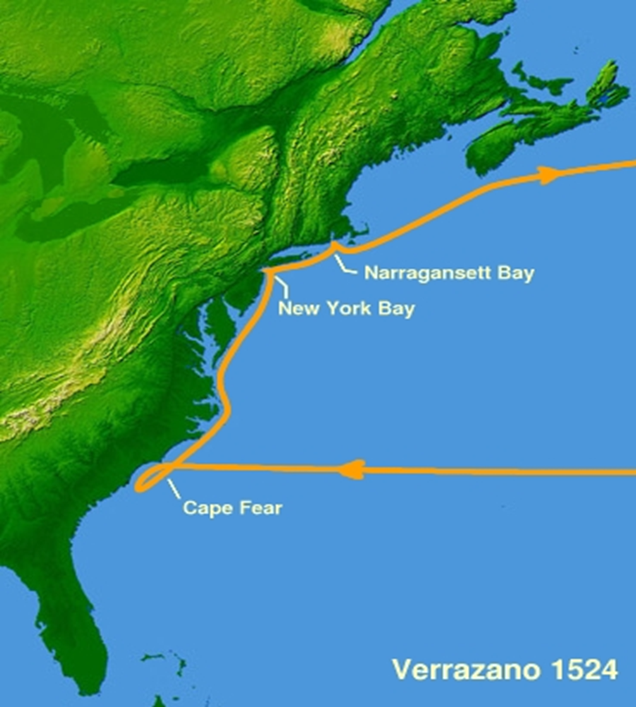

Verrazano questions

1. What previous explorer was well know to him and may hav e influenced him?

2. What product did Verrazano hope to bring back?

3. Which French King granted permission and funding for his trip?

4. In his first voyage, he was forced to turn back. Why?

5. What did Verrazano do to try and avoid conflit with ther Spanish?

6. “Verrazano was to develop the habit of going ashore in a small boat to explore and greet the natives, while most of his crew remained behind on the ship. It was a practice that would ultimately prove fatal.” Why?

7. Verrazano did not name new places after saints and other reolgious figures. How did he name them?

8. Verrazan spent a lot of his efforts describing the native peoples. What are some words he used to describe them?

