CORONADO AND THE SEVEN CITIES OF CIBOLA

There were many rumors or stories about treasure in the land north of Mexico. When the Spaniards heard these stories, they sent expeditions to search for the gold. One famous story told about the Seven Cities of Gold.

The story begins when four men survived a shipwreck off the coast of what is today known as Texas. They were three Spaniards, and a North African named Esteban. After the shipwreck, the four men walked across Mexico until they arrived in Mexico City in 1536. During their journey, they heard stories along the way about seven cities rich in gold, silver and jewels.

When the four men arrived in Mexico City, they told the story of the Seven Cities of Gold to the Spanish leaders. In 1539, the leaders of the city sent Esteban and a priest named Marcos de Niza to investigate the rumor. Esteban was killed by Indians during the expedition. But Marcos de Niza returned to Mexico City. He lied and reported he had seen the golden city.
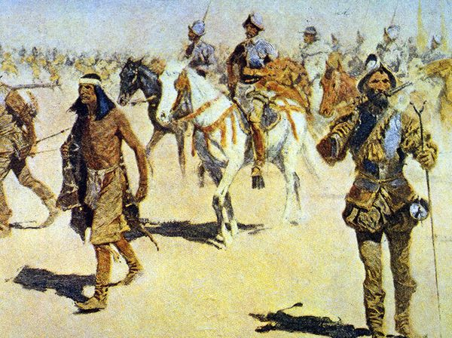
In 1540, Francisco Coronado and
more than 1,000 soldiers set out to
find the Seven Cities of Gold.

They traveled north out of Mexico
into the present-day states of
Arizona, New Mexico, Texas,
Oklahoma and parts of Kansas.

Coronado's expedition included
300 Spanish soldiers on
horseback, and 1,000 black slaves
and Mexican Indians. They took
thousands of cattle and sheep to use for food. After one year of travel,
they ran out of food. Then they fought with the Indians for food. Using their
crossbows and guns, the Spaniards won.

Although they searched through Arizona and New Mexico, they never found the Cities of Gold.

They never saw any traces of the Seven Cities of Gold. Coronado then took the long trip home. The route he took back toward Mexico would later become known as the Santa Fe Trail.

In 1542, Coronado returned to Mexico with only 100 of his soldiers. Coronado never found the Seven Cities of Gold. However, he did claim the lands he had traveled through for Spain. This prevented any other European country from making claims to the American southwest

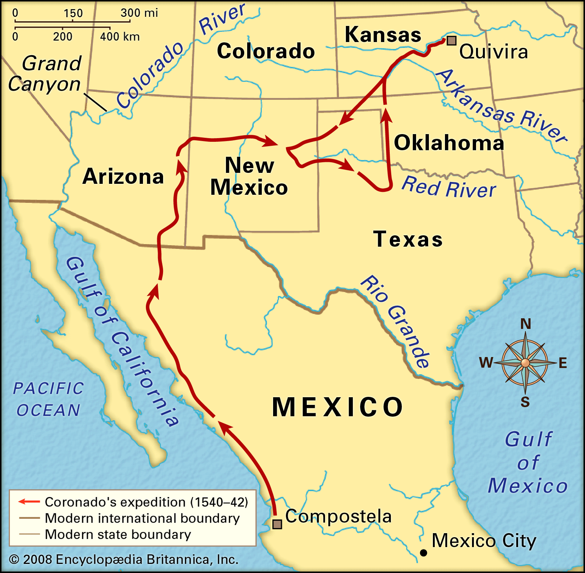

The Seven Cities of Cibola

- Who were the four men shipwrecked in the Gulf of Mexico?
2. How did they hear of the seven cities?
3. Why was Frey Marcos? What did he do?
4. Who was Estevanico?
5. What eventually happened to him?
6. The Seven Cities eventually turned out to be what?

