FERDINAND MAGELLAN Biography

While in the service of Spain, the Portuguese explorer Ferdinand Magellan led the first European voyage of discovery to circumnavigate (travel around) the globe. His voyage provided clear proof that the Earth is round.

Early life and travels

Ferdinand Magellan was born in Portugal. His parents were very wealthy. Young Magellan found himself in the service of the King and Queen. He was twelve when he began serving the queen of Portugal as a page- a position of employment for children. Magellan was encouraged to learn subjects that would help him greatly later, such as cartography (mapmaking) and astronomy .

Fighting for Portugal

Magellan joined the Portuguese navy. He went to East Africa and later was in a battle in which the Portuguese destroyed the Egyptian fleet. Magellan was wounded in a battle in North Africa. But all of his services to Portugal brought him little favor from the Portuguese king, so he went to Spain, to offer his services to the King and Queen.

Exploring for Spain

Spain and Portugal were both great powers at this time. They were in great competition over the rights to claim and settle the newly "discovered" regions.

In 1494 the Treaty of Tordesillas divided the world of the "discoveries" between the two powers, splitting the globe in half. Portugal acquired everything from Brazil eastward, while the Spanish hemisphere of discovery and conquest ran westward from Brazil. The parts of this area had not yet been explored by the Spaniards, and they assumed that some of the Spice Islands, a source of great spices, might lie within their half of the globe. Magellan's plan was to test that idea. He decided that the best way to reach these islands was to sail in a westward

Other explorers had paved the way for Magellan by making key mistakes and discoveries.

Christopher Columbus had badly underestimated the distance between Europe and the East, sailing westward from the European coast and "discovering" North America and the Caribbean islands (West Indies).

Vasco Balboa's (1475–1517) revealed the existence of the Pacific Ocean, which he had claimed for Spain. Explorers eagerly looked for a water passage to reach the spice-rich East. Magellan also sought such a passage

Magellan's great voyage

King Charles of Spain approved Magellan's proposal. In September 1519, Magellan led a fleet of five ships into the Atlantic. Unfortunately, the ships were no really good to sail long distances, and the crew were not all loyal to Magellan. The fleet sailed down the South American coast. During this time, some members of the crew tried to take over the ships but they were not successful. . Afterwards, however, one ship was wrecked, and its crew had to be taken aboard the other vessels.

Crossing the Pacific

The fleet sailed southward and entered what is now called the Strait of Magellan. The fleet proceeded carefully, taking over a month to pass through the strait. During this time another ship deserted so only three of the original five ships entered the Pacific.
It took 3 months to cross the Pacific with great hardship, reaching the island of Guam. The crew ran out of food during the trip and many were sick.

The Philppines

Magellan then headed to the Philippines, where, in an effort to gain become friends with a local ruler, he became involved in a local war and was killed in battle in April 1521. The remaining crew was forced to return on one ship. They finally reached Spain in September , 1522.

What did Magellan's voyage accomplish?

Magellan's project brought little in the way of money to Spain. Yet despite nearly destroying itself in the process, the Magellan fleet for the first time revealed the full size of the globe. As a scientific effort, it proved to be the greatest of all the "conquests" undertaken by the overseas adventurers.
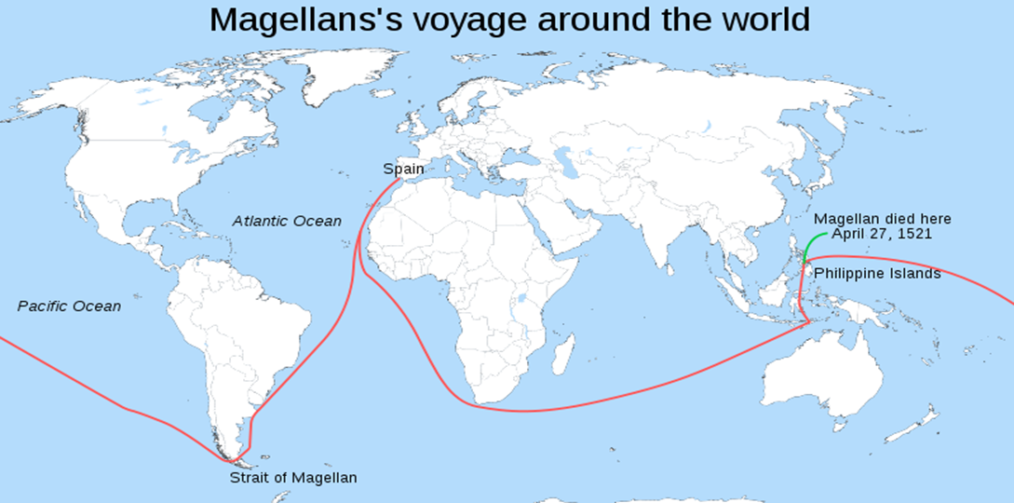

FERDINAND MAGELLAN biography
1. From what country was Magellan?
2. What subjects did he study that would help his with his navigation later?

3. What kind of military experience did he have?

4. Why did Magellan sail for Spain?

5. In what ways did other explorers pave the way for Magellan?

6. How many ships did he take on his voyage?
7. What problems did he have on his voyage as he reached Brazil?

8. What hardships did he suffer while crossing this ocean?

9. What happened to Magellan in the Philippine Islands?

