CHRISTOPHER COLUMBUS biography

Christopher Columbus made four trips across the Atlantic Ocean from Spain. He was determined to find a water route west from Europe to Asia, but he never did. Instead, he accidentally stumbled upon the Americas. Though he did not really “discover” the New World–millions of people already lived there, his journeys marked the beginning of centuries of conquest and colonization.

During the 1400 and 1500s, leaders of many European nations paid for trips over the ocean hoping that explorers would find great wealth and undiscovered lands.

The Portuguese were the earliest to get involved in this “Age of Discovery.” Starting in 1420, small Portuguese ships known as caravels sailed along the African coast, carrying spices, gold, slaves and other goods from Asia and Africa to Europe. Other European nations, like Spain, were eager to share in the riches of the “Far East.”

Christopher Columbus: Early Life

Christopher Columbus, the son of a wool merchant, was born in Italy in 1451. When he was still a teenager, he got a job on a ship. He remained at sea until 1470, when French pirates attacked his ship. The boat sank, but the young Columbus floated to shore on a scrap of wood and made his way to the city of Lisbon, where he studied math, astronomy, map-making and navigation. He also began to think of the plan that would change the world forever.

Christopher Columbus: The First Voyage

At the end of the 1400s, it was nearly impossible to reach Asia from Europe by land. The route was long and dangerous. Portuguese explorers solved this problem by taking to the sea: They sailed south along the West African coast and around the bottom of Africa

Columbus had a different idea: Why not sail west instead of around Africa?

His idea was good, but his math was not correct. He argued that the distance around the Earth was much smaller than other believed it was.

Columbus believed that the journey by boat from Europe to Asia should be easy. He presented his plan to officials in Portugal and England, but it was not until 1491 that he found someone interested in his idea: the Spanish King and Queen

Columbus wanted fame and fortune. King Ferdinand and Queen Isabella did too, along with the chance to spread their religion to lands across the globe. Columbus was very religious and was also excited about this possibility. Spanish rulers promised Columbus he could keep 10 percent of whatever riches he found.

In August, Columbus and his crew set sail from Spain in three ships: the Nina, the Pinta and the Santa Maria. In October, the ships made landfall….not in Asia, as Columbus believed, but on one of the Bahamian islands. For months, Columbus sailed from island to island, looking for the pearls, precious stones, gold, silver, spices, and other objects, but he did not find much. In March 1493, leaving 40 men behind, he returned to Spain.

Christopher Columbus: Later Voyages

Six months later, in September 1493, Columbus returned. He found the 40 men he left behind had been killed. To this day, no one knows what happened there and why his men were killed. He headed west to continue his search for gold and other goods. He returned home 500 slaves for Queen Isabella. The queen was horrified. She believed that any people Columbus “discovered” were Spanish subjects who could not be enslaved so she promptly returned the explorer’s gift.

In May 1498, Columbus sailed west across the Atlantic for the third time. He returned to the settlement he had built to find the colonists had a bloody revolt against Columbus. Conditions were so bad that Spanish authorities had to send a new governor to take over. Columbus was arrested and returned to Spain.

In 1502, cleared of any charges, Columbus convinced the Spanish king to pay for one last trip across the Atlantic. This time, Columbus made it all the way to Panama–just miles from the Pacific Ocean–where he had to abandon two of his four ships in the face of an attack from hostile natives. Empty-handed, the elderly explorer returned to Spain, where he died in 1506.

Christopher Columbus: Legacy

Christopher Columbus did not “discover” the Americas, nor was he even the first European to visit the “New World.” Viking explorers had sailed to Greenland and Newfoundland in the 11th century. However, his journey kicked off centuries of exploration and exploitation on the American continent.
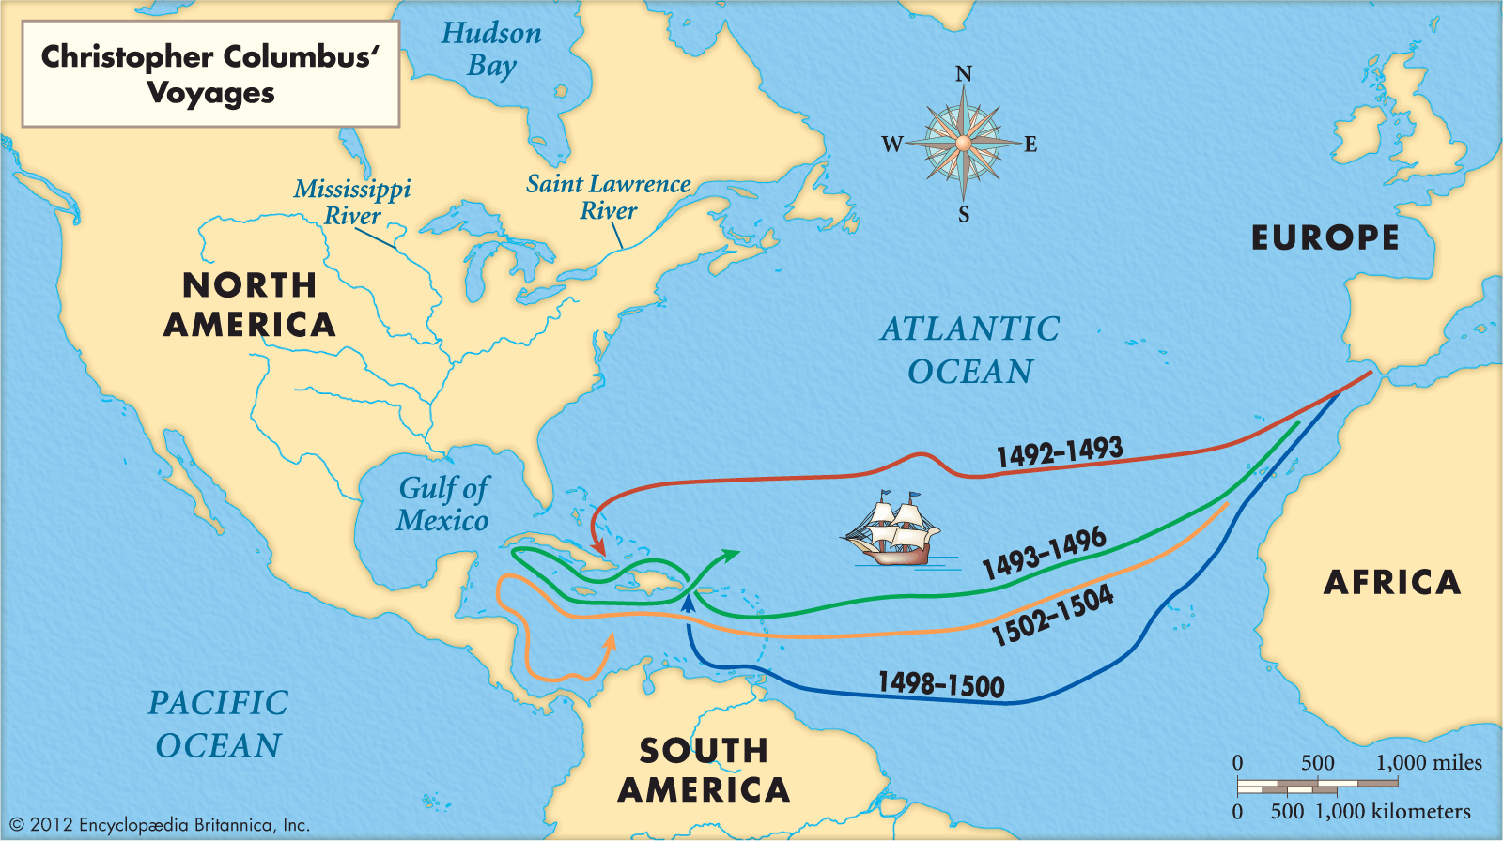

- How many journeys did Columbus eventually make to the New World?

- Which country was the first to enter the "Age of Discovery?"

- Describe the incident that happened to him in his early life that almost cost him his life.

- How did Columbus' calculation differ from the real size of Earth?

- What "reward" was Columbus supposed to receive if he successfully reached India and China?

- When he could not find riches in the New World, what did he send back to Spain instead?

- How did the Queen react to this gift?

- What happened on his third voyage?

