CALL TO FREEDOM
CHAPTER 8
SECTION 4 RATIFICATION OF THE CONSTITUTION

BEFORE YOU READ….
Answer these questions to see how much you might already know about this topic

TRUE FALSE
___ ___ 1. Most of the people who opposed the Constitution were wealthy
___ ___ 2. Alexander Hamilton was opposed to a large central government
___ ___ 3. Each state held their own vote for or against the new Constitution
___ ____ 4. Delaware was the first state to ratify the new Constitution
___ ___ 5. The Bill of Rights got some states to support the Constitution

Why do you think this picture means?

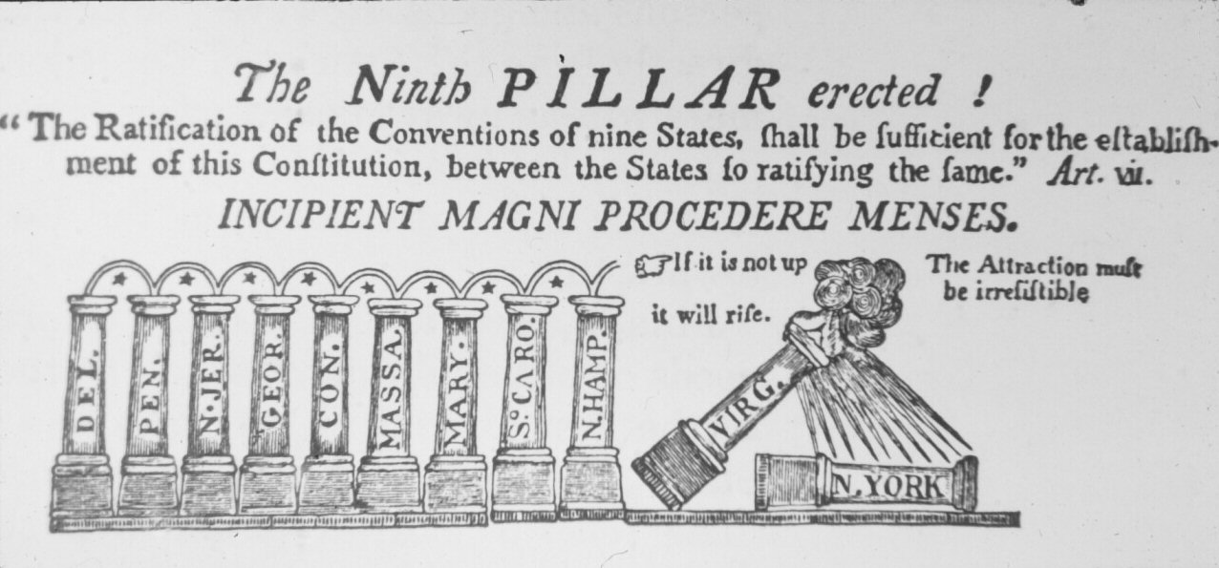

READ PAGES 242-247 IN YOUR TEXTBOOK AND ANSWER THE QUESTIONS

Federalists and Antifederalists
VOCABULARY
DEBTORS: PEOPLE WHO OWED MONEY

Main idea: What were some of the Antifederalists argument against the Constitution?
- What were the three arguments that troubled antifederalists about the new Constitution?
1.

2.

3.

- What kind of occupations did antifederalists have?

- Name 4 famous figures from the Revolutionary War who were anti-federalists

- What did the Federalists believe about the Constitution?

- Name 5 famous figures from the Revolutionary War who were federalists

The Federalist Papers
VOCABULARY
TRANQUILITY: PEACE

Main idea: How did the Federalists Papers defend the Constitution?
- What was the “fake” name used as the author of these essays?

- Who really wrote these essays?

- In Federalist #10 (the 10th essay in the Federalists Papers), Madison explained why one group could not take over the country. How did he explain this?

- In Federalist #15 (the 15th essay in the Federalists Papers), What did Hamilton suggest about the former Articles of Confederation?

The Ratification Fight
VOCABULARY
RATIFICATION: THE PROCESS OF AGREEING TO ACCEPT THE CONSTITUTION AS THE LAW OF THE LAND

Main idea: In what order did the states ratify the Constitution, and which states ratified the Constitution after it went into effect?
- After the Articles of Confederation was written, it was required that all states approve it. How many states were required to approve the new Constitution?

- How did each state decide whether or not to approve the Constitution?

- Which state became the FIRST to ratify the Constitution?

- What state made the Constitution the official law of the land?

- Why was it extremely important to get both Virginia and New York to approve the Constitution?

Who helped convince New York?
Who helped convince Virginia?

Demanding and Bill of Rights
Main idea: Why some people feel a bill of rights was necessary and how was it added to the Constitution?
VOCABULARY
PERVERSION: ABUSE

- What did antifederalists fear the new Constitution could not do?

- Why did Federalists believe a bill of rights was not necessary?

- Madison believed that the bill of rights could be added as amendments. What was the process for amending (changing) the Constitution?

- How many amendments were originally proposed?

- How many were eventually accepted?

