CALL TO FREEDOM
CHAPTER 8
SECTION 2 PROBLEMS IN THE NEW NATION
What kind of problems would be caused by each state printing their own money?

BEFORE YOU READ….
Answer these questions to see how much you might already know about this topic

TRUE FALSE
___ ___ 1. After the Revolutionary War, the British refused to remove their troops from America
___ ___ 2. Few nations treated us with any respect
___ ___ 3. A Tariff is often used to encourage people to buy products made here in America
___ ____ 4. Printing more money makes the value of the money stronger
___ ___ 5. Rebellion by farmers led to great changes in our government

Here is a picture of currency printed by different states
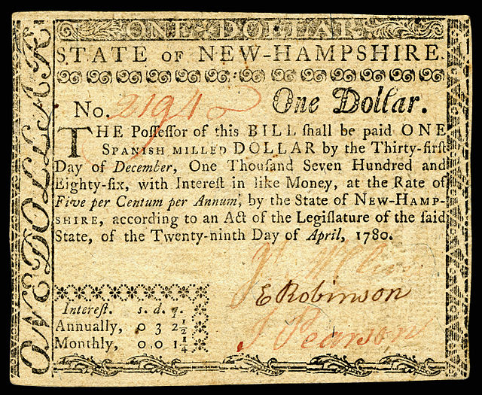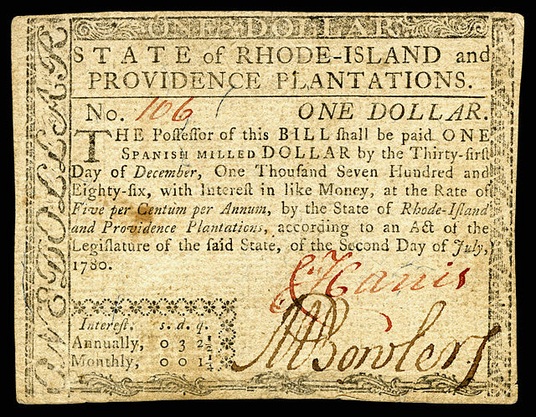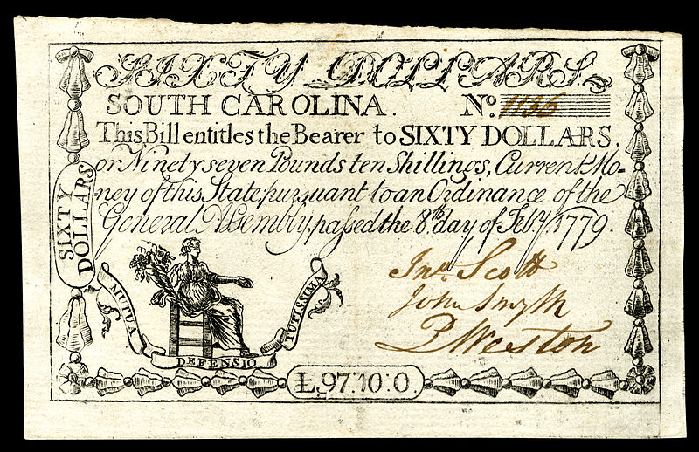

READ PAGES 230-235 IN YOUR TEXTBOOK AND ANSWER THE QUESTIONS

A Lack of Respect
VOCABULARY
SUBSTANCE: MEANING

Main idea: How did the weakness of the Articles of Confederation affect US relations with other countries?
- What happened to Thomas Amis?

- Why couldn’t the country do something to protect Thomas Amis?

- According to the Treaty of Paris which ended the Revolutionary War, when were the British supposed to remove their armies from North America?

- Why couldn’t our country enforce this International treaty?

- What did Spain do that hurt our new country?

- Why couldn’t we stop Spain from doing this?

- How did Spain’s decision have an impact on American farmers and merchants?

- How did other nations treat our new country?
Trouble with Trade
VOCABULARY
DUTIES: TAXES ON ITEMS BROUGHT INTO THE COUNTRY
TARIFF: TAXES ON ITEMS BROUGHT INTO THE COUNTRY

Main idea: What trade problems did the United States face with Great Britain and why did these occur
- The British West Indies was an important trade stop for American merchants, but after the war, what did the British do that hurt our trade there?

- What goods did we trade with the British that were now heavily taxed?

- What do you think this tariff did to the price of these goods?

- What did farmers now have to do if they wanted to transport and sell their goods in the British West Indies?

- When the British began selling their manufactured goods cheaply in America, what happened to our own manufactured goods?

- A tariff raises the price of goods that come into your country. If we wanted to keep British goods from being sold here in America, why didn’t our Congress simply pass a tariff?

- What did Great Britain do when some states passed their own tariff?

Economic Problems at Home
VOCABULARY
COMMERCIAL: INTENDING TO MAKE A PROFIT
INFLATION: WHEN THE PRICE OF PRODUCTS INCREASE
WOES: TROUBLES
DEBTORS: PEOPLE WHO OWE MONEY
CREDTORS: PEOPLE WHO ARE OWED MONEY
DEPRESSION: WHEN THE NATIOAL ECONOMY SLOWS DOWN AND PEOPLE LOSE THEIR JOBS BECAUSE BUSINESSES CLOSE

Main idea: What led to the economic differences between the states and how did these affect the National economy?
- Since Congress could not regulate trade between the states, each state made their own rules. What kind of problems would this cause?

- Why did states print their own money?

- What kind of problems would be caused by states printing their own money?

- What happened to the value of the money when states printed more of it?

- How would this have impacted prices?

Debt in Massachusetts
VOCABULARY
INENTURED SERVANT: PEOPLE WHO WILLINGLY ENTER INTO A CONTRACT TO WORK FOR A PERIOD OF TIME TO PAY OFF THEIE DEBTS
DEBTORS PRISONS: PLACES WHERE PEOPLE WHO COULD NOT PAY BACK LOANS OR MONEY THEY OWED
BANKRUPT: OUT OF MONEY
RURAL: IN THE COUNTRY

Main idea: What caused the problems in Massachusetts?
- Since Massachusetts refused to print paper money like other states, how did they try and raise money to pay their war debts?

- How did new taxes impact farmers in Massachusetts?

- Since there was no paper money, what did people use for money?

- What happened to farmers who could not pay their taxes?

- Read the petition from a rural town (bold print). What does the petition say (or warn) about the future of farmers (and others) in the state?

- Why did many politicians not seem to care about the local farmers?

Shays Rebellion
VOCABULARY
UPRISING: A REBELLION
MORTIFIED: EMBARASSED
TYRANTS: EVIL, MEAN RULERS

Main idea: What was Shay’s rebellion and why was it so important?
- When farmers in Massachusetts closed down the courts, what were they trying to prevent?

- How did the government first react (what did they tell Shays and others?)

- What did the state government’s threat do for Shays rebellion?

- What happened to many of the rebels that were caught by the government?

- Why did George Washington react with embarrassment about this event?

- What was Thomas Jefferson’s view of the event?

- How did Shays rebellion demonstrate the weakness of our national government?

- What did people now want because of this rebellion?
A Push for Change
VOCABULARY
HESITATED: WAITED
DELEGATES: REPRESENTATIVES
ADEQUATE: ENOUGH

Main idea: How did the states address the problems of the central government?
- A national conference was called for the purpose of discussing the problems of the Articles of Confederation. Where did it meet?

- Who attended this conference?

- The delegates at the conference concluded there should be another meeting. Where was this supposed to happen?

- Who was supposed to attend?

