CALL TO FREEDOM
CHAPTER SEVEN
SECTION 4 THE PATRIOTS GAIN NEW HOPE

BEFORE YOU READ….
Answer these questions to see how much you might already know about this topic

TRUE FALSE
___ ___ 1. Washington’s army almost completely quit on him during the war.
___ ___ 2. Washington’s victory at Trenton was a great deal of luck and little skill.
___ ___ 3. He victory at Saratoga was a turning point in the war.
___ ____ 4. Valley Forge was a huge victory for the colonists.
___ ___ 5. The colonists were able to get the French to join them during to fight the war.

Look at this picture
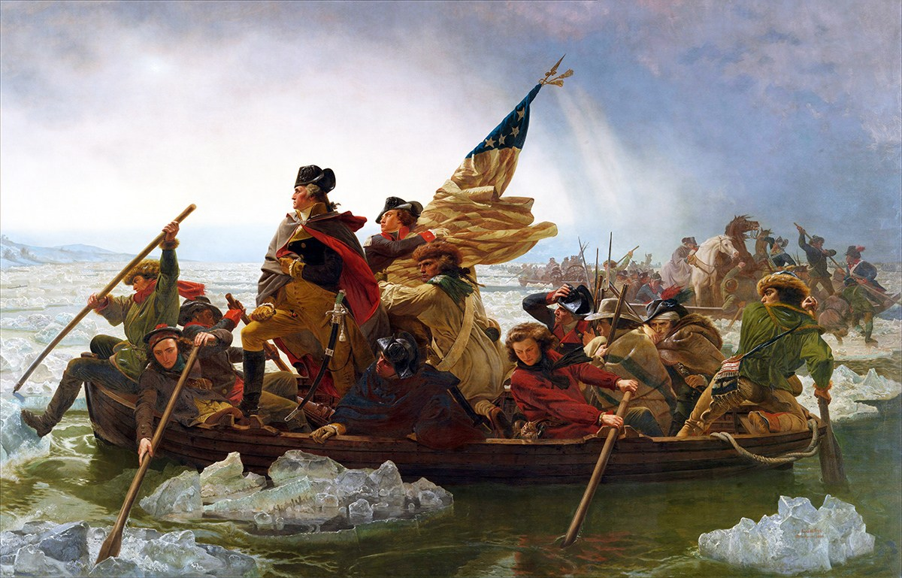

What were some of the dangers (risks) seen in this picture?

Victory in New Jersey
VOCABULARY
MERCENARY: A SOLDIER THAT IS PAID TO FIGHT FOR A WAR FOR THE COUNTY OTHER THAN THEIR OWN.

Main idea: What was General Washington’s plan at Trenton and Princeton?
- Where did General Howe and most British troops spend the winter of 1776?

- Who were the Hessians and where were they from?

- What did Washington do while General Howe waited (delayed)?

- Why did Washington decide to attack the Hessians in Trenton?

- What was the significance of the date he attacked them?

- Under what conditions did the colonial army fight
- What were the results of the battle of Trenton?

- How did Washington fool the British into believing he was still in Trenton while all along he was on his way to surprise the British at Princeton?

- What were the results of the battle at Princeton?

Turning Point at Saratoga
VOCABULARY
OUTNUMBERED: THEY HAVE MORE THAN YOU

MORALE: FIGHTING SPIRIT

Main idea: Why was Saratoga the turning point of the war?
- How did the British feel about the losses at Trenton and Princeton?

- When the British decided to strike back after these losses, what was their plan?

- What was the target (city) of all three British armies?

- What happened to Washington at the battle of the Brandywine (creek)?

- Why was British General Burgoyne forced to surrender at Saratoga?

Foreign Allies
VOCABULARY
DELEGATES: REPRESENTATIVES

WELFARE: GOOD

Main idea: How did foreign aid (help) impact the war against England?
1. Who did colonists send to France to try and convince them to help us?

2. What convinced the French to finally join the Patriot's cause?

3. Who was the Marquis de Lafayette?

4. Who were Tadeusz Kosciuszko and Kazimierz Pulaski?

- What hardships did the colonists suffer in the winter at Valley Forge?

- What contribution did Baron Friedrich von Steuben make to the Patriot cause?

The Winter at Valley Forge
VOCABULARY
HARSH: VERY COLD WEATHER CONDITIONS

Main idea: What challenges did the Continental army face at Valley Forge?

- What shortages did the Continental army face at Valley Forge?

- Who was Baron von Steuben?

- What impact did Baron von Steuben have on the army?

The War at Sea
VOCABULARY
MERCHANT SHIPS: SHIPS TRANSPORTING GOODS AND SUPPLIES

RAIDING VESSELS: SHIPS THAT WOULD ATTACK MERCHANT SHIPS

Main idea: How did the actions of John Paul Jones show the strategy of the Patriots at sea?
- How many fighting ships did the colonists have at the start of the war?

- What did the colonists do instead of trying to fight large battles with the British navy?

- What impact did small raiding vessels have on the British shipping?

- How did John Paul Jones become a naval hero?

