CALL TO FREEDOM
CHAPTER SEVEN
SECTION 1 THE REVOLUTION BEGINS

BEFORE YOU READ….
Answer these questions to see how much you might already know about this topic

TRUE FALSE
___ ___ 1. Colonists asked the King one more time to consider their complaints
___ ___ 2. Some colonists helped the British to locate colonial trouble-makers
___ ___ 3. The British started the war by firing on the colonists
___ ____ 4. George Washington was chosen to lead the colonial army
___ ___ 5. The colonists did well (won) most of the early battles of the war

INTERPRETING A CARTOON

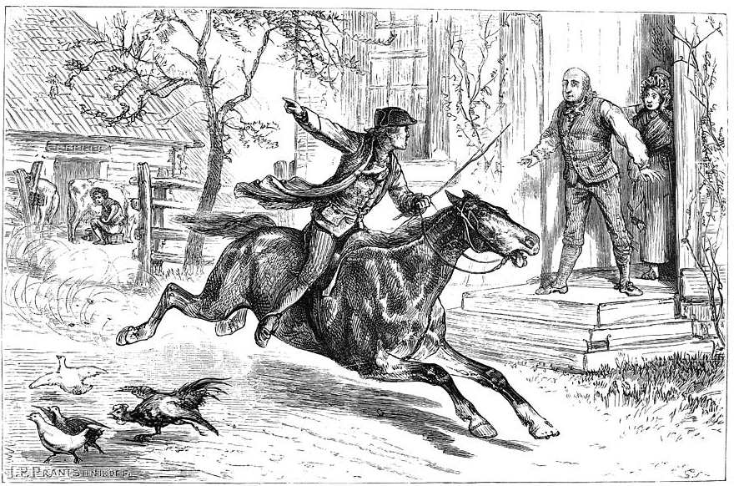

What is the story behind this picture?

The First Continental Congress
VOCABULARY
- DEBATE: ARGUE

RESOURCE: SOMETHING YOU CAN USE

COMPROMISE: AGREE UPON

Main idea: What did the First Continental Congress accomplish?
1. Where did the colonists meet in September of 1774?

2. What did they call this meeting?

3. Which of the 13 colonies did not attend?

4. What two things did the colonists decide to do after this meeting?
1.

2.

5. What was contained in the Declaration of Rights?

6. When were the colonists supposed to meet again?

The Shot Heard Round the World
VOCABULARY
CASUALTIES: PEOPLE HURT OR KILLED IN BATTLE

Main idea: What led to the fighting at Lexington and Concord?
1. Who were the "minutemen? (How did they get that name?)

2. Why did British General Gage want to send his troops to Concord?

3. When the colonists found out what General Gage was doing, what did they do to warn Concord that the British were on their way?

4. When the British arrives in Lexington on the morning of April, who was waiting for them?

5. What happened once both sides fired upon each other at Lexington?

6. When the British arrived at Concord, why didn't they find the weapons the colonists were storing there?

The Second Continental Congress
VOCABULARY
PETITION: FORMAL COMPLAINT

Main idea: Why did King George reject the Olive Branch Petition?

1. When colonists met again in Philadelphia for the Second Continental Congress, who did they chose to lead their army?

2. Colonists made a final attempt at peace with a note to the King. What was it called?

3. How did the King react to this offer?

Early Battles
VOCABULARY
ASTONISHED: GREATLY SURPRISED

Main idea: How did the geography influence the early battles?
1. What does "siege" mean?

2. What were the colonists doing on Breed's (Bunker) Hill?

3. Why did the colonists have to retreat when the British attacked?

4. What lesson did the colonist learn from Bunker Hill?

5. Where did Washington get the cannons he used to drive the British out of Boston?

6. What did he do at Dorchester Heights?

7. Why was General Howe, the British commander, so astonished at what the colonists had done?

