CALL TO FREEDOM
CHAPTER TWO
SECTION 2 VOYAGE TO THE AMERICAS
Pages 38-43
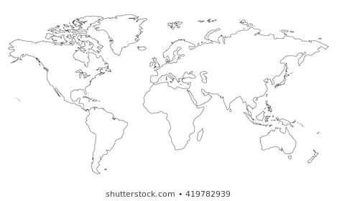

BEFORE YOU READ….
Answer these questions to see how much you might already know about this topic

TRUE FALSE
___ ___ 1. Columbus received several offers from nations in Europe to fund his voyage
___ ___ 2. Spain turned down Columbus at first because they were at war
___ ___ 3. Columbus almost drown on his first voyage
___ ____ 4. The King and Queen of Spain were happy about Columbus bringing them slaves
___ ___ 5. Columbus’ voyage started a war between Spain and Portugal

Circle the area on the map below where Columbus landed

COLUMBUS’ BOLD IDEA
VOCABULARY
RECONQUISTA: Spain won back control of territory from Muslims (Moors) who had taken it earlier

VICEROY: A governor
Main idea: What did King Ferdinand and Queen Isabella hope to gain from Columbus; trip?
1. Why were some people unwilling to try and cross the Atlantic Ocean?

2. Why did the King and Queen of Spain ignore Columbus for six years?

3. Did Columbus have any luck convincing other European nations to support him?

4. Why did the King and Queen of Spain change their mind and decide to hire Columbus? (What event changed their mind?)

5. What things did they ask Columbus to bring back to Spain?

6. What did they tell him to do if he found new land?

7. What did they agree to pay him?

8. What title did they agree to give him if he succeeded?

CROSSING THE OCEAN
VOCABULARY
- CRAMPED: Lots of people stiffed into a small area

1. Complete these fast facts about his journey
Ship names:
____________
____________
_________________
Number of crew members: _______
Date he left: _________________
Date he arrived: _______________
Amount of supplies he brought _______________

2. How did the crew react to the length of this voyage?

COLUMBUS’ FIRST EXPLORATIONS
VOCABULARY
- SAN SALVADOR: Spanish words for “Holy Savior”

FABLED: As told in stories

Main idea: What interested Columbus most on his first voyage to America?
1. Where did Columbus land?

2. What did he call the area where he landed?

3. Who were the Taino?

4. What did Columbus call them? Why did he call them this?

5. How did Columbus describe these people?

6. How did Columbus feel about their culture?

7. How did he get them to help him?

8. What did Columbus find in his explorations?

9. Why didn’t the ship Santa Maria return to Spain?

EUROPE LEARNS OF COLUMBUS’ VOYAGE
VOCABULARY
- BOASTING: Bragging

CONVERT: Change your beliefs

DEMARCATION: To draw boundary lines

Main idea: What was done in response to Portugal’s unhappiness with the Line of Demarcation?
1. How did the King and Queen of Spain react to the items Columbus brought them?

2. How did they reward him?

3. What did the Queen want to do with the Taino who returned with him to Spain?

4. How is this different from what Columbus wanted to do with them?

5. What was the purpose for drawing the Line of Demarcation?

6. Why did the King of Portugal object to it?

7. How did the Treaty of Tordesillas fix King John’s complaint?

COLUMBUS’ LATER VOYAGES
Main idea: Why were the later voyages of Columbus less successful than the first?
VOCABULARY

UNSUNG: Not celebrated or recognized for an achievement

1. When he returned to the New World in 1493, what did Columbus discovery about the crew he had left behind?

2. Upon his return, how did Columbus treat the Taino?

3. How did Columbus’ actions violate the orders the Queen gave him?

4. What did the King and Queen do that showed their anger with Columbus?

5. Although Columbus was wealthy near the end of his life, he did not participate in any royal ceremonies? Why?

