CALL TO FREEDOM
CHAPTER 10 LAUNCHING THE NATION
SECTION 3 TROUBLES ABROAD

BEFORE YOU READ….
Answer these questions to see how much you might already know about this topic

TRUE FALSE
___ ___ 1. The French Revolution was caused by the American Revolution
___ ___ 2. During the French Revolution, the King of France was put to death
___ ___ 3. When England and France went to war, President Washington supported France
___ ____ 4. England took sailors from American ships and put them in the British navy
___ ___ 5. The treaty we made with England was not very popular

Look at the map below.
Why do you think the Mississippi River was so important to farmers in North America?

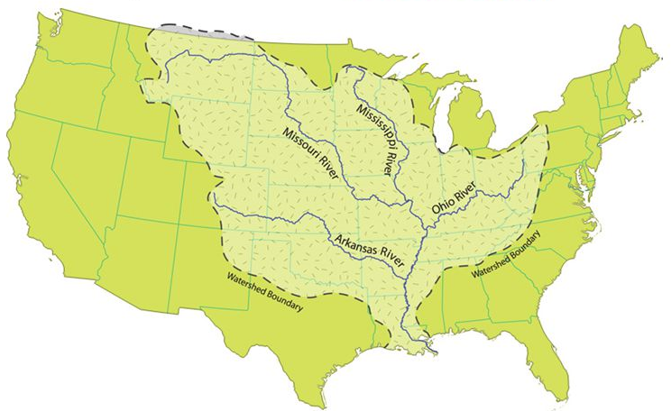

READ PAGES 310-314 IN YOUR TEXTBOOK AND ANSWER THE QUESTIONS
The French Revolution
VOCABULARY
BASTILLE: THE FRENCH FORTRESS THAT WAS ATTACKED BY THE PEOPLE OF FRANCE. THIS STARTED THE FRENCH REVOLUTION.

OPPRESSIVE: INFLICTING HARDSHIP ON THE PEOPLE

REVOLUTIONAIRES: PEOPLE WHO PARTICIPATE IN THE VIOLENT OVERTHROW OF THE GOVERNMENT

Main idea: What differing opinions did Americans hold about the French Revolution?
- Where did the French people get their ideas about liberty and democracy?

- How did some American celebrate the French Revolution?

- Why were many US citizens upset or worried about the French Revolution?

- What happened to the French King (Louis XVI)?

US Neutrality
Main idea: What was the reasoning behind neutrality?
- After the French Revolution, which two European countries went to war?
VOCABULARY
NEUTRALITY: NOT TAKING SIDES IN AN ARGUMENT

PROCLAMATION: AN OFFICIAL ANNOUNCEMENT OF GREAT IMPORTANCE

- Which side did Washington feel the United States should join in this war?

- What did the Neutrality Proclamation say?

Citizen Genet
Main idea: What did President Washington do when France and Great Britain went to war and how did Thomas Jefferson react?
- What was Edmund Genet’s official position in the government?

- What were privateers (what did they do?)

- What did Genet do that made Washington so upset?

Jay’s Treaty
Main idea: How What parts of Jay’s Treaty benefitted the United States and which parts did not?
- What were 2 things that the British were doing that made it seem that we were going to go to war with them?
1.

2.

- What two things did the British agree to do as a result of Jay’s Treaty?
1.

2.

- What did the United States agree to do as a result of Jay’s Treaty?

- There were many critics of the treaty. What were the flaws in the treaty the critics pointed out? (things the treat did not accomplish)

Pinckney’s Treaty
VOCABULARY
DISPUTED: ARGUED OVER

Main idea: What did most American believe Pinckney’s Treaty was more successful than Jay’s Treaty?
- What caused Spain to close the port of New Orleans to US trade?

- Why was New Orleans such an important port?

- Who was Thomas Pinckney (what was his role in the government)?

- What does “right of deposit” mean?

- Why did the Spanish finally sign a treaty which allowed for the right of deposit? (What convinced them to do this?)

