BIZARRE SUPREME COURT CASES

PGA Tour Inc v Martin (1893)
Background of the case
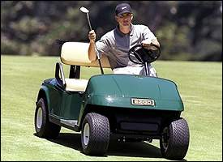
Casey Martin is afflicted with a degenerative circulatory disorder that prevents him from walking golf courses.
His disorder constitutes a disability under the Americans with Disabilities Act of 1990 (ADA).
When Casey made a request to use a golf cart for the duration of the qualification tournament onto the professional tours sponsored by PGA Tour, Inc., PGA refused.
The PGA Tour claimed that Martin would not only have an unfair advantage against his competition, but would remove one of the fundamental aspects of golf: walking.
Martin then filed suit under the ADA, which requires an entity operating
"public accommodations" to make "reasonable modifications" in its policies "when... necessary to afford such...accommodations to individuals with disabilities, unless the entity can demonstrate that making such modifications would fundamentally alter the nature of such...accommodations."
Ultimately, the District Court ruled against PGA, requiring it to allow Martin to use a cart. The court found that the purpose of the PGA's walking rule was to insert fatigue into the skill of shot-making, and that Martin suffered significant fatigue due to his disability, even with the use of a cart.
The Court of Appeals concluded that golf courses are places of public accommodation during professional tournaments and that permitting Martin to use a cart would not fundamentally alter the nature of those tournaments.
How would you rule on this?

