BIZARRE SUPREME COURT CASES

Nix v Hedden (1893)
Background of the case
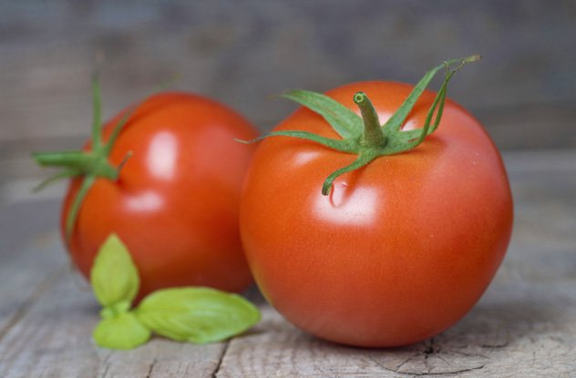
John Nix was the founder of the John Nix and Company in New York City, which opened in 1839. John Nix and Company. was one of the largest sellers of produce in New York City at the time, and was one of the first companies to ship produce from Virginia, Florida, and Bermuda to New York.
The Tariff Act of 1883 required a tax to be paid on imported vegetables, but not fruit. The tax was 10% of the value of the good.
The case was filed by John Nix, John W. Nix, George W. Nix, and Frank W. Nix against Edward L. Hedden, Collector of the Port of New York, to recover taxes (money) paid under protest.
A dictionary definition declares a tomato is a fruit because it is a seed-bearing structure growing from the flowering part of a plant.,,,,so the tomato is as much a fruit as an apple or a banana is—as is the pumpkin, the cucumber, the zucchini, and the chili pepper.
At the trial, the lawyers for Nix, after reading in evidence definitions of the words "fruit" and "vegetables" from Webster's Dictionary, Worcester's Dictionary, and the Imperial Dictionary, called two witnesses, who had been in the business of selling fruit and vegetables for 30 years.
Both sides made use of the dictionaries, exploring the definitions of the words pea, eggplant, cucumber, squash, pepper, potato, turnip, parsnip, cauliflower, cabbage, carrot and bean.

How would you rule on this?
The court's decision
The single question in this case is whether tomatoes, considered as provisions, are to be classed as 'vegetables' or as 'fruit,' within the meaning of the tariff act of 1883.
Witnesses called at the trial testified that neither 'vegetables' nor 'fruit' had any special meaning in trade or commerce different from that given in the dictionaries.
The passages cited from the dictionaries define the word 'fruit' as the seed of plaints, or that part of plaints which contains the seed, and especially the juicy, pulpy products of certain plants, covering and containing the seed. These definitions have no tendency to show that tomatoes are 'fruit,' as distinguished from 'vegetables,' in common speech, or within the meaning of the tariff act.
There being no evidence that the words 'fruit' and 'vegetables' have acquired any special meaning in trade or commerce, they must receive their ordinary meaning.
Botanically speaking, tomatoes are the fruit of a vine, just as are cucumbers, squashes, beans, and peas. But in the common language of the people, whether sellers or consumers of provisions, all these are vegetables which are grown in kitchen gardens, and which, whether eaten cooked or raw, are, like potatoes, carrots, parsnips, turnips, beets, cauliflower, cabbage, celery, and lettuce, usually served at dinner in, with, or after the soup, fish, or meats and not, like fruits generally, as dessert.
As an article of food on our tables, whether baked or boiled, or forming the basis of soup, they are used as a vegetable, as well when ripe as when green. This is the principal use to which they are put.

