AMERIGO VESPUCCI

America was named after Amerigo Vespucci, An Italian navigator and explorer who played a major role in exploring the New World.

Explorer Amerigo Vespucci was born in 1451, in Florence, Italy. In 1497, he embarked on his first voyage. On his third and most successful voyage, he discovered present-day Brazil. Believing he had discovered a new continent, he called it the New World. In 1507, America was named after him.

Vespucci and his parents were friends of the wealthy family, who ruled Italy. While his older brothers headed off to the university, Vespucci received his early education from his paternal uncle.

In the late 1490s, Vespucci worked with merchants who supplied Christopher Columbus on his later voyages. Vespucci had the opportunity to meet Columbus. The conversation sparked Vespucci's interest in seeing the world with his own eyes. Vespucci, enticed by the prospect of fame, decided to leave his business behind and become an explorer before it was too late.

Voyages

In 1497, Vespucci left on his first journey with a fleet of Spanish ships. Vespucci claims that his ships sailed made their way to Central America within five weeks. If true, this would mean that Vespucci discovered America year before Christopher Columbus did.

In 1499 Vespucci began another expedition, as a navigator. During this journey Vespucci is said to have discovered the Amazon River.

In 1501, Vespucci departed on another journey—this time for the King of Portugal. Vespucci's third voyage is largely considered his most successful. Vespucci's ships sailed along the coast of South America. Believing he had discovered a new continent, Vespucci called South America the New World.

Vespucci decided to start recording his accomplishments, writing that accounts of his voyages would allow him to leave "some fame behind me after I die."

In 1503, sailing again for Portugal, Vespucci headed back to Brazil. When the expedition didn't make any new discoveries, the fleet split up

Naming America

In 1507, some mapmakers in France were working on a geography book which contained large cut-out maps. One of the book's authors proposed that the newly discovered Brazilian portion of the New World be labeled America, the feminine version of the name Amerigo, after Amerigo Vespucci. The was his way of honoring the person who discovered it.

Decades later, in 1538, the mapmaker Mercator, chose to mark the name America on both the northern and the southern parts of the continent, instead of just the southern portion. While the definition of America expanded to include more territory, Vespucci seemed to gain credit for areas that most would agree were actually first discovered by Christopher Columbus.

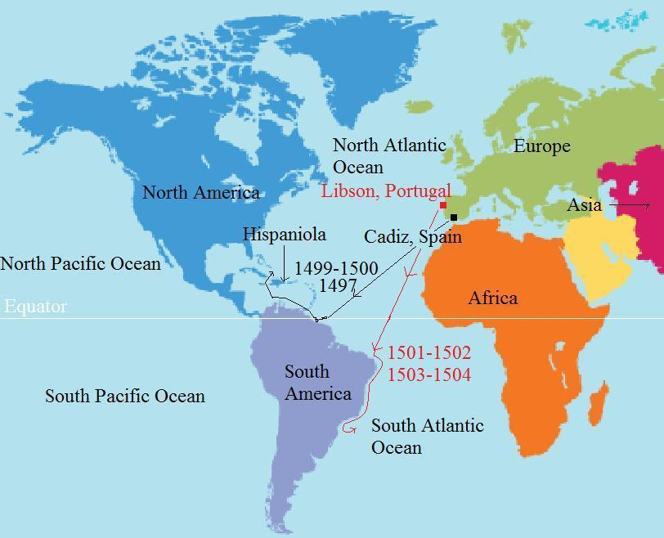

AMERIGO VESPUCCI biography

- Where did Vespucci land in his third voyage?

- What did he call the land he discovered?

- What explorer did he meet when he was young?

- How did this meeting affect his life?

- We know for sure that he made three voyages though there are some that believe he made many more. What countries did he sail for in these voyages?

6. Explain how the region “America” got its name from Vespucci.

