A BRIEF HISTORY OF NEW NETHERLANDS

The Dutch in America: From Discovery to the First Settlement, 1609-1621

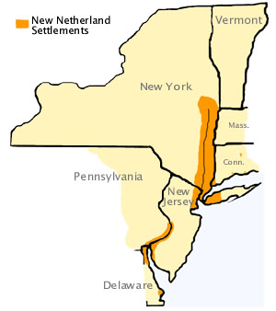

In 1602 the East India Company created a
mission to explore a passage to the
Indies (for spices) and claiming any
territories for the Dutch.

On September 3, 1609, the English
explorer Henry Hudson, on behalf of the
East India Company, entered the area
now known as New York to find a
northwest passage to the Indies.

He searched every coastal river and bay
and took his ship up the river which is now
named after him, claiming the land for the
company.

Although no passage was discovered, the area turned out to be one of the best fur-trading regions in North America.

Years later, merchants from Amsterdam created The New Netherland Company for fur trading in the region Hudson had explored.

The company built Fort Orange near Albany and began trading with the Indians for furs. Although merchants came to New Netherland for business purposes, the area was not colonized. The land was opened to all Dutch traders.

Eventually the Dutch government decided to give the land to a company that would bring people to the area to live.

The Dutch West India Company and Colonization
In 1621 the newly created Dutch West India Company obtained trading rights in America. In 1623 the company began organizing the first permanent Dutch settlement in New Netherland. In 1624, a ship, departed with the first wave of settlers, 50 families. These families were spread out over the entire territory claimed by the company. Later, six additional ships sailed with colonists, livestock and supplies.
It soon became clear the northern and southern outposts had to be abandoned due to a war between Indian tribes. The women and children were forced to move to safety. At this point, Peter Minuit, came to the area.
Motivated to create a safe place for the families, Minuit purchased the island of Manhattan from the Indians for some 60 guilders worth of trinkets. He immediately started the construction of Fort New Amsterdam.

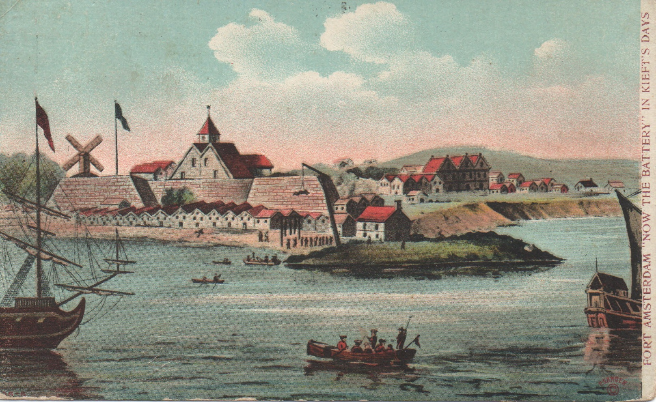

Because of the hardships of life in the new land some colonists decided to return to the homeland. By 1630 the total population of New Netherland was about 300 farmers.

New Netherland was a business, run on a for profit by the directors of the West India Company.

Their goal was to make a profit for the investors who had purchased shares in the company. The West India Company (WIC) paid skilled individuals, like doctors and craftsmen, to move to New Netherland and also sent over and paid soldiers for military protection of the settlements; the company also built forts and continually sent over supplies for the settlers.

Laws were made by the company-appointed Director General with the approval of the company directors in Amsterdam. The company profit was whatever was left
after expenses had been paid

WIC discovered the expenses were too high. To increase their profits, the company sought to increase the population through partnerships called the
Patroonship plan.

The Patroonship plan was a way to attract more settlers without increasing company expenses. Under the plan, a Patroon would be granted a large amount
of land and given the rights similar to a lord of a manor.

In return, the Patroon would agree to bring over settlers and colonize the land at his own expense.

Under the Patroonship plan, New Netherland continued to expand. They also established a whaling village on the southern shore of Delaware Bay near what is now Lewes, Delaware.

Merchants
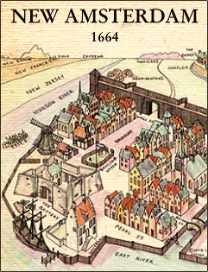
New Netherland settlers did not
come to America because of religious
persecution, nor were they poor.

They came to make money.

The majority were single males,
mostly tradesmen or farmers.

The West India Company negotiated
to bring these people over because
the company felt they would be useful
in building an economy that would turn a
profit for the company.

These individuals felt this was an opportunity to make their fortune.

The West India Company provided cattle, horses, provisions and land to farmers. The farmers repaid the company as soon as possible.

For craftsmen, a salary was negotiated and housing arrangements were made making them company employees.

About one half of the population was not Dutch. The population of the colony was between 2,000 to 3,500 in 1655, growing to about 9,000 by 1664. A significant number of the inhabitants were Germans and Swedes.
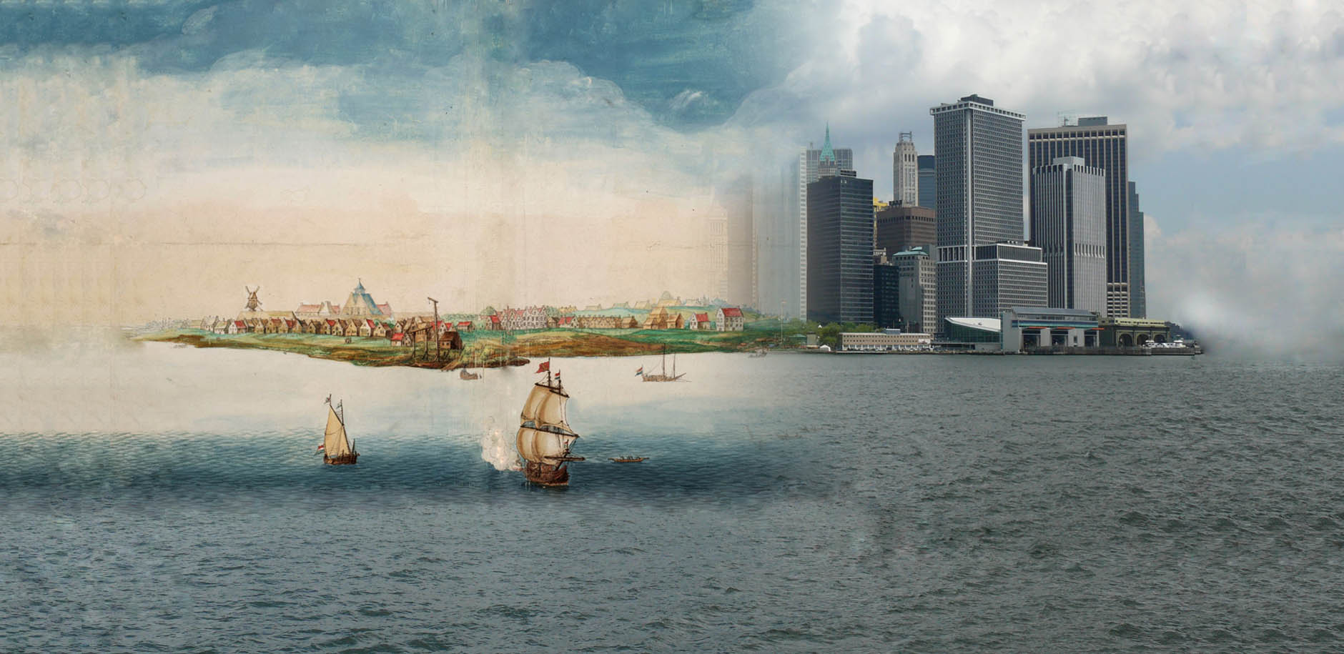

British Claims and Conquest
As New Netherland prospered, the British set their sights on the region. They felt the region was actually theirs because of the early explorations of John Cabot. Cabot, working for Britain, had explored the coast of the new world in 1498. Over 100 years before the Dutch arrived. The British felt they had prior claim to the land.
In the mid-Seventeenth century the British and Dutch saw each other as direct competitors, consequently several times during this period they were at war. The two nations were trading rivals and were suspicious of each other.
In 1664, England openly claimed New Netherland as British property and granted it to his brother James, Duke of York and Albany (later James II).
The Duke sent a fleet to seize the colony. In September 1664, the Director General Pieter Stuyvesant surrendered Fort Amsterdam. The city of New Amsterdam and the entire colony were renamed New York.

The British governor arrived in Manhattan and gave the Dutch a week to leave.

From that point, the British controlled all of New York. New York City remained a British military stronghold in America.

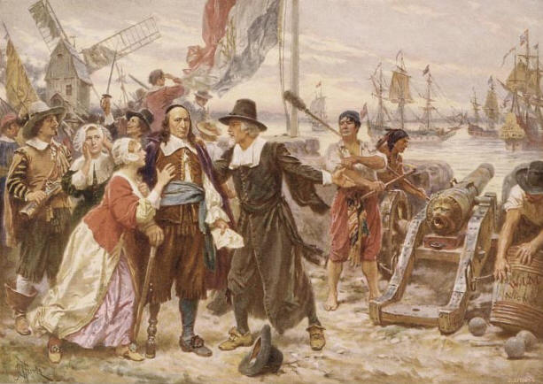

QUESTIONS:

1. Who did the East India Company hire to search for a passage to the Indies?
2. How did the West India Company eventually end up with the rights to colonize this area?
3. What forced Peter Minuit to buy the island of Manhattan?

4. Describe how New Amsterdam was settled. Explain how the company supported the new colony.

5. Who were the people put in charge of managing the colony?
6. Explain how the Patroonship plan was designed to work.
What powers were Patroons granted?
What incentive did they have to come to America?

7. What steps did the WIC create incentives for people to come to America?

8. Besides the Dutch, what other nationalities lived in this region?
9. What gave the British a claim to this region?
10. What steps did England take to possess this territory?

11. How did the area get the name we call it today (New York)?
12. Were the English right to take this territory from the Dutch? (your opinion)

13. Take a look at the picture at the bottom of the third page.
What does it represent?

