10 FACINATING FACTS ABOUT THE AZTECS
The Aztecs are best known for eating chocolate, killing boatloads of people in sacrifice to their gods and eventually getting beaten by the Spaniards. They are known by most as a warlike race, mostly due to the incredible amount of people they killed. However, contrary to popular belief, they were not without culture.
The Aztecs believed strongly in education, family and art. Even their system of slavery was very detailed.
Listed below are ten interesting facts about the Aztecs.

10. Artistic
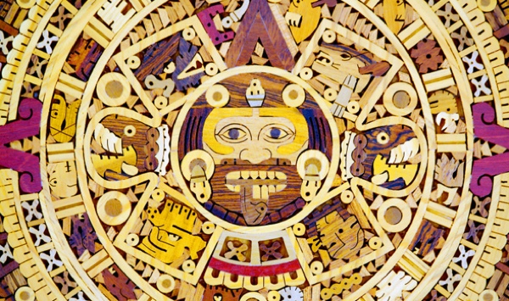

The Aztecs played sports
and were a very artistic people

Despite the idea of Aztecs being
savages, they were a very artistic people. Aztecs were into pottery
and sculpting and created many
different artistic drawings as well.

They designed art for their warriors and applied tattoo’s to honor them for their accomplishments; they also had a love for poetry.

The Aztecs also played team sports, specifically a game very popular among them called Ullamaliztli.

The game utilized a rubber ball and was played on a court called a Tlachtli. The object of the game was to get the ball through a small stone ring; however, it was an extremely difficult game to play. The ball was not supposed to hit the ground, and players could only touch it with their head, elbows, knees and hips.

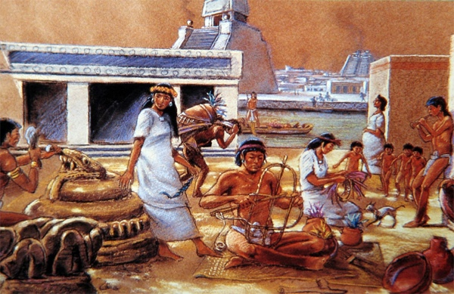

9 Mandatory Schooling

Aztecs had mandatory
schools separated
between boys and girls.

Aztecs had mandatory public
schooling for all children.

Those of a noble class had
different schools to attend and schools were also separated by gender.

Boys of nobility learned from the priests about history, astronomy, art, and how to govern and lead. Boys of lower caste preparing for service in the military as warriors. Girls were sent to separate schools and much more of their education was focused at home where they were taught duties such as cooking and weaving.

8. Defeated by Disease

Most Aztecs were actually defeated by disease, not war.
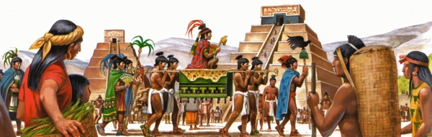
If not for the smallpox contracted from the Europeans that wiped out so many of them, especially their leaders, that it is extremely unlikely they would have fallen to the Spanish. The amount of harm caused by European diseases was tremendous, it is estimated that over twenty million Mexicans died in a period of just five years due to the diseases brought over by the Spanish.

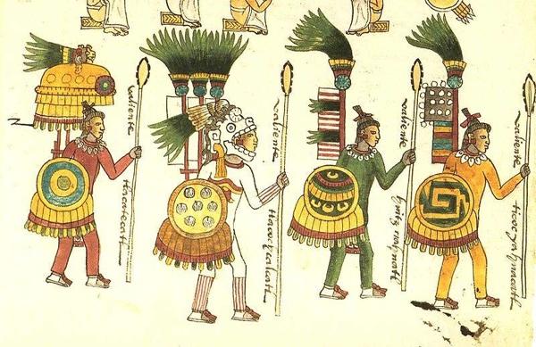

7. Wrong Name

The Aztecs never referred to
themselves as Aztecs.

We all know the Aztecs by that name,
but it was not actually a name that they
ever called themselves.

The Aztecs themselves actually
referred to themselves as Mexica,
which is actually where the name for the country of Mexico originally came from.

6 Advanced Record Keeping

They had an advanced
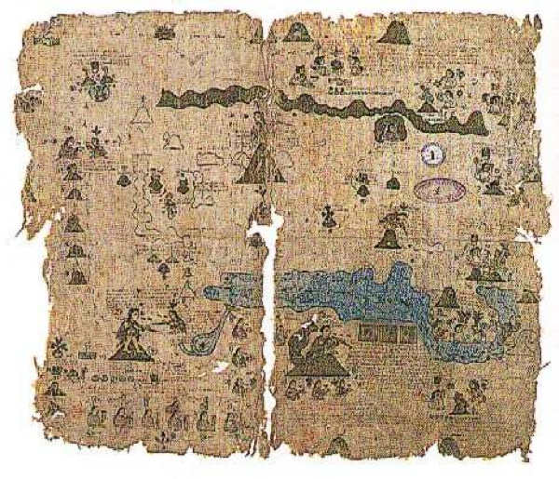
system for writing and
keeping records.

The Aztecs had their own language

Knowledge on how to write things
down was mostly performed by
scribes, who had the needed training.

Records were kept on paper made of
bark, or deer skin.

The writing was usually performed
using charcoal and then colored with vegetables and other substances. They kept tax records, historical records, kept information written down on religious sacrifices and other ceremonies and even wrote poetry.

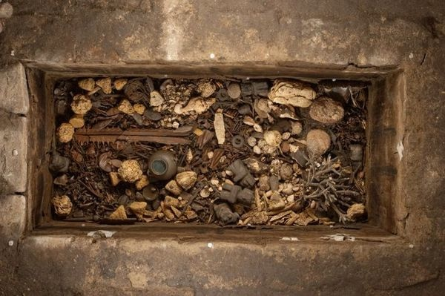
5 Burial Customs

The Aztecs had very
strange burial customs.

The Aztecs cared little
about having things built
on top of their graves.

In fact, the Aztecs made
a habit of burying their
ancestor’s right under
and around their houses. Sometimes the Aztecs would also kill a dog and bury
with the person so that it could guide them on their journey through the afterlife.

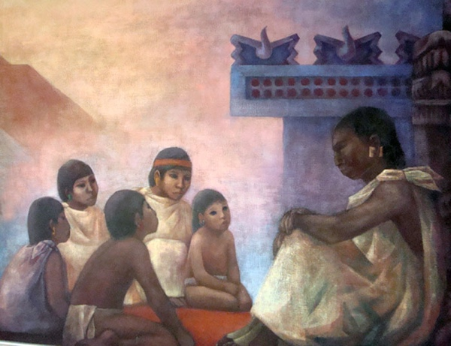
4 Sell Children

They would often sell their own
children into slavery.

Someone who was poor to sell their own
children into slavery. Many Aztecs would
also sell themselves into slavery.

Someone would go bankrupt and sell themselves or their children into slavery would give them some income.
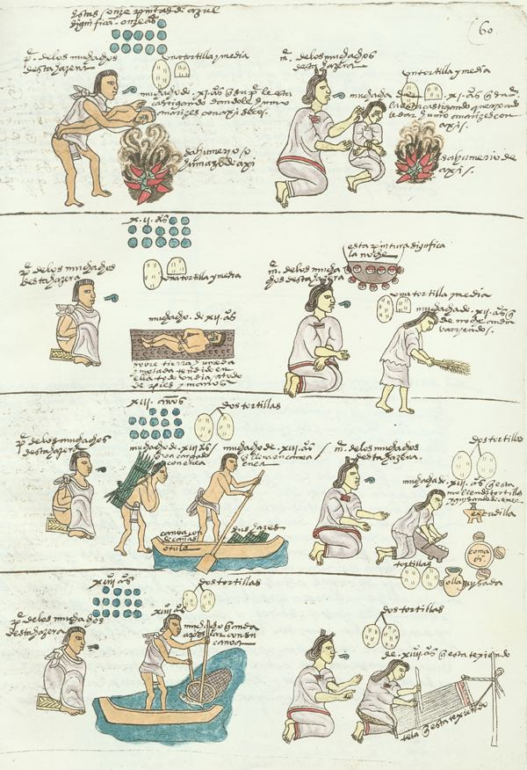

3 Polygamy

Aztec men practiced polygamy.

Aztec men were allowed to have more than
one wife, however, there were certain strict
rules governing these relationships.

The first wife the man took was considered
his “principal” wife, and was the only one he
went through marriage ceremonies with.

2 Slavery
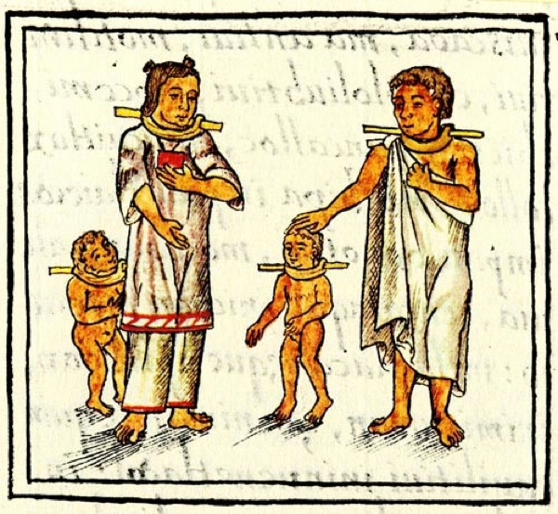

Aztecs had a unique system for slavery.

Slavery among the Aztecs was much different
than that of the Europeans and followed much
different rules.

Slaves children were not automatically property,
and slaves could own possessions and even own
other slaves.

If a slave tried to run away, only the master or his relatives were allowed to chase after them.

.

1 Human Sacrifice
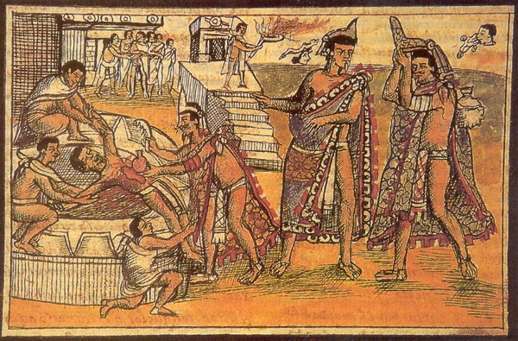
Aztec sacrifices were rituals to their gods and kept people under control.
Roughly 20,000 people were sacrificed by the Aztecs every year.
The people who were sacrificed were often eaten, as part of the sacrificial ritual.

